**CC:**

**Question 1:**

package com.code.code;

import org.openqa.selenium.By;

import org.openqa.selenium.WebDriver;

import org.openqa.selenium.chrome.ChromeDriver;

import org.openqa.selenium.chrome.ChromeOptions;

import io.github.bonigarcia.wdm.WebDriverManager;

public class CC {

public static void main(String[] args) throws InterruptedException {

ChromeOptions co = new ChromeOptions();

co.addArguments("--remote-allow-origins=*");

WebDriverManager.chromedriver().setup();

WebDriver driver = new ChromeDriver(co);

driver.get("https://www.saucedemo.com/");

driver.manage().window().maximize();

driver.findElement(By.xpath("//input[@id=\"user-name\"]")).sendKeys("standard_user");

driver.findElement(By.xpath("//input[@id=\"password\"]")).sendKeys("secret_sauce");

driver.findElement(By.xpath("//input[@id=\"login-button\"]")).click();

Thread.sleep(3000);

driver.findElement(By.xpath("//button[@id=\"add-to-cart-sauce-labs-backpack\"]")).click();

Boolean addToCart = driver.findElement(By.xpath("//*[@id=\"remove-sauce-labs-backpack\"]")).isDisplayed();

System.out.println("Is user able to add product to cart : " + addToCart);

driver.findElement(By.xpath("//*[@id=\"shopping_cart_container\"]/a")).click();

driver.findElement(By.xpath("//*[@id=\"checkout\"]")).click();

driver.findElement(By.xpath("//*[@id=\"first-name\"]")).sendKeys("Sriram");

driver.findElement(By.xpath("//*[@id=\"last-name\"]")).sendKeys("M");

driver.findElement(By.xpath("//*[@id=\"postal-code\"]")).sendKeys("627005");

driver.findElement(By.xpath("//*[@id=\"continue\"]")).click();

System.out.println(driver.findElement(By.xpath("//*[@id=\"item_4_title_link\"]/div")).getText());

System.out.println(driver.findElement(By.xpath("//*[@id=\"checkout_summary_container\"]/div/div[2]/div[8]")).getText());

String etitle = "Swag Labs";

String atitle = driver.getTitle();

if(etitle.equals(atitle)) {

System.out.println("Title is matching");

}

else {

System.out.println("Title Mismatch");

}

String eurl = "https://www.saucedemo.com/checkout-step-two.html";

String aurl = driver.getCurrentUrl();

if(eurl.equals(aurl)) {

System.out.println("URL is matching");

}

else {

System.out.println("URL Mismatch");

}

}

}

**Output:**

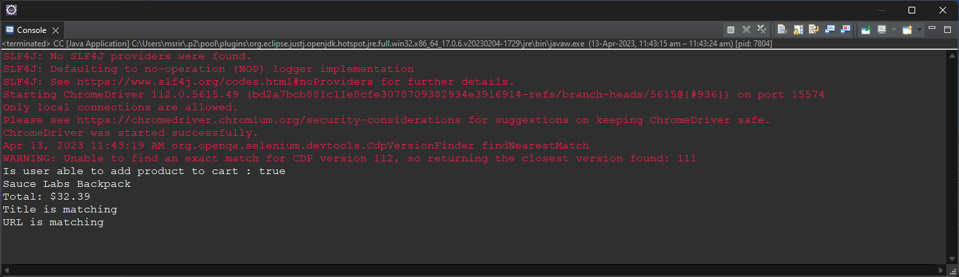

**Question 2:**

package com.code.code;

import org.openqa.selenium.By;

import org.openqa.selenium.WebDriver;

import org.openqa.selenium.chrome.ChromeDriver;

import org.openqa.selenium.chrome.ChromeOptions;

import io.github.bonigarcia.wdm.WebDriverManager;

public class CC2 {

public static void main(String[] args) throws InterruptedException {

ChromeOptions co=new ChromeOptions();

co.addArguments ("--remote-allow-origins=*");

WebDriverManager.chromedriver().setup ();

WebDriver driver=new ChromeDriver(co);

driver.get ("https://www.saucedemo.com/");

driver.manage().window().maximize() ;

driver.findElement(By.xpath("//*[@id=\"user-name\"]")).sendKeys("standard_user");

driver.findElement(By.xpath("//*[@id=\"password\"]")).sendKeys("secret_sauce");

driver.findElement(By.xpath("//*[@id=\"login-button\"]")).click();

System.out.println("First one in A -> Z :" + driver.findElement(By.xpath("//*[@id=\"item_4_title_link\"]/div")).getText());

driver.findElement(By.xpath("//*[@id=\"header_container\"]/div[2]/div/span/select")).click();

driver.findElement(By.xpath("//*[@id=\"header_container\"]/div[2]/div/span/select/option[2]")).click();

Thread.sleep(2000);

System.out.println("First one in Z -> A :" + driver.findElement(By.xpath("//*[@id=\"item_3_title_link\"]/div")).getText());

driver.findElement(By.xpath("//*[@id=\"header_container\"]/div[2]/div/span/select")).click();

driver.findElement(By.xpath("//*[@id=\"header_container\"]/div[2]/div/span/select/option[3]")).click();

System.out.println("First one in price Low to High:" + driver.findElement(By.xpath("//*[@id=\"item_2_title_link\"]/div")).getText());

driver.findElement(By.xpath("//*[@id=\"header_container\"]/div[2]/div/span/select")).click();

driver.findElement(By.xpath("//*[@id=\"header_container\"]/div[2]/div/span/select/option[4]")).click();

System.out.println("First one in price High to Low:" + driver.findElement(By.xpath("//*[@id=\"item_5_title_link\"]/div")).getText());

}

}

**Output:**

